2018



Prepared by the Partners of the EPA’s Decentralized Wastewater MOU Partnership

**MOU Partners’ SepticSmart Week Social Media Guide**

Contents

How to Use this MOU Partnership Guide 2

What You Should Know About SepticSmart Week 2

SepticSmart Week Core Messages 2

Know Your Audience 2

Social Media for MOU Partners to Use During SepticSmart Week 3

Hashtag 3

Twitter Messages 3

Facebook/ LinkedIn/ Instagram Posts 4

Website Homepages & Web graphics 5

Blogs 6

Using Education to Strengthen Emergency Preparedness for Septic Systems 6

Teaming Up: How Partnerships Benefit Water Quality through Decentralized System Improvement 7

On-site Septic Drainfield Innovations Around Vermont’s Lakes and Ponds 8

How to Guide: Governor, Mayor & Local SepticSmart Week Proclamations 10

Monthly Planning Guide to a SepticSmart Week Proclamation 10

Other Tips and Ideas to Promote SepticSmart Week 11

Outreach Materials 11

Images & Graphics 12

TV Spots 12

Press Releases, Public Service Announcements (PSAs) & Radio Advertisements 12

Press Release 12

Public Service Announcements (PSAs) 14

Radio Ads 14

Talking Points for MOU Partners 15

Personalize It! 15

Track Your Social Media Reach 15

Promotional Examples 16

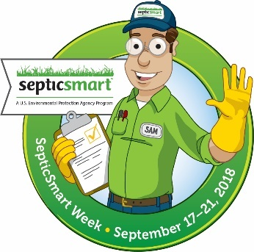**Decentralized Wastewater MOU Partners’ SepticSmart Week Social Media Guide**

# **How to Use this MOU Partnership Guide**

Welcome! As a Decentralized Wastewater MOU Partner or affiliate of the Decentralized Program, this SepticSmart Week Social Media Guide contains material and information your organization can use to advertise and promote SepticSmart Week. In addition to the basic social media messages and outreach material, it includes tips and methods to track the information you share on your social media channels. You can either copy these messages directly or customize them to reach your audience. Have fun and remember to be SepticSmart!

# **What You Should Know About SepticSmart Week**

SepticSmart Week is an annual event focused on educating homeowners and communities on the proper care and maintenance of their septic systems. Federal, state and local governments, the private sector, communities and academia, all participate in SepticSmart Week. You can participate too by sharing these social media messages, promoting the outreach information and advertising SepticSmart Week.

# **SepticSmart Week Core Messages**

* Protect It & Inspect It! (Day 1)
* Think at the Sink! (Day 2)
* Don’t Overload the Commode! (Day 3)
* Pump Your Tank! (Day 4)
* Don’t Strain Your Drain! (Day 5)
* Shield Your Field! (Day 6)
* Keep It Clean! (Day 7)

These are the core messages to promote during SepticSmart week using the associated social media materials and images. The MOU Partners suggest focusing on one core message per day of SepticSmart Week. You’ll see in the other sections (as above) that a core message is selected for each day. Core message Quick Tips are available in both English and Spanish on Page 12 of this guide.

# **Know Your Audience**

One of the first things to consider with social media is identifying the audience you are trying to reach. Are you targeting professionals? Pumpers? Installers? County public health officials? Individual homeowners? Tailor your social media messages so you provide your audience with relevant tips, facts and resources to assist them in getting out the core messages of SepticSmart Week.

# **Social Media for MOU Partners to Use During SepticSmart Week**

**From Katie Foreman (ACWA) and EPA**

## **Hashtag**

* Official hashtag: #SepticSmart

## **Twitter Messages**

* Remember, twitter messages or “tweets” are 140 characters or less!
* **One week in advance (September 10, 2018)**
  + Do you have a septic system? Join us for #SepticSmart Week, September 17-21! Learn how you can participate at https://www.epa.gov/septic
  + [Save the Date PDF](https://www.epa.gov/sites/production/files/2018-01/documents/septicsmart_week_2018_save_date_010318.pdf)
* **Four days in advance (September 13, 2018)**
  + Do Your Part. Get Septic Smart! Join us next week for #SepticSmart Week and learn septic system quick tips at https://www.epa.gov/septic
  + [Save the Date PDF](https://www.epa.gov/sites/production/files/2018-01/documents/septicsmart_week_2018_save_date_010318.pdf)
* **Day 1 / September 17, 2018 / Protect It and Inspect It!**
  + Today we're kicking off #SepticSmart Week! Look for our Quick Tips to stay #SepticSmart year-round https://www.epa.gov/septic
  + #SepticSmart Tip: Protect It and Inspect It! Save money and protect the environment! https://www.epa.gov/septic
  + [TO POST on Twitter: Protect It and Inspect It (JPEG)](https://www.epa.gov/sites/production/files/styles/large/public/2018-04/protect_it_and_inspect_it_2018.jpg)
* **Day 2 / September 18, 2018 / Think at the Sink!**
  + Think at the sink! Limit use of your garbage disposal. Get the scoop on #SepticSmart maintenance by visiting <https://www.epa.gov/septic>
  + [TO POST on Twitter: Think at the Sink (JPEG)](https://www.epa.gov/sites/production/files/styles/large/public/2018-04/think_at_the_sink_2018.jpg)
* **Day 3 / September 19, 2018 / Don’t Overload the Commode!**
  + Don't overload the commode! Know what should and shouldn’t go in your toilet and stay #SepticSmart at https://www.epa.gov/septic
  + [TO POST on Twitter: Don't Overload the Commode (JPEG)](https://www.epa.gov/sites/production/files/styles/large/public/2018-04/dont_overload_the_commode_2018.jpg)
* **Day 4 / September 20, 2018 / Pump Your Tank!**
  + #SepticSmart Tip: Pump Your Tank! Get your septic system pumped every 3-5 years to maintain its lifespan! https://www.epa.gov/septic
  + [TO POST on Twitter: Pump Your Tank (JPEG)](https://www.epa.gov/sites/production/files/styles/large/public/2018-04/pump_your_tank_2018.jpg)
* **Day 5 / September 21, 2018 / Don’t Strain Your Drain!**
  + Don’t Strain Your Drain! The more water you conserve, the less ends up in your septic tank. Stay #SepticSmart https://www.epa.gov/septic
  + [TO POST on Twitter: Don't Strain Your Drain (JPEG)](https://www.epa.gov/sites/production/files/styles/large/public/2018-04/dont_strain_your_drain_2018.jpg)
* **Day 6 / September 22, 2018 / Shield Your Field!**
  + Shield Your Field! Learn more about what can damage your septic system. Be #SepticSmart https://www.epa.gov/septic
  + [TO POST on Twitter: Shield Your Field (JPEG)](https://www.epa.gov/sites/production/files/styles/large/public/2018-04/sheild_your_field_2018_-_2.jpg)
* **Day 7 / September 23, 2018 / Keep It Clean!**
  + Keep it Clean! Test your drinking water well to keep your family healthy. More #SepticSmart tips at https://www.epa.gov/septic
  + [TO POST on Twitter: Keep it Clean (JPEG)](https://www.epa.gov/sites/production/files/styles/large/public/2018-04/keep_it_clean_2018.jpg)

## **Facebook/ LinkedIn/ Instagram Posts**

* **One week in advance: (September 10, 2018):**
  + Did you know one in five U.S. homes have septic systems? Yours may be one of them. Next week we are kicking off #SepticSmart Week to encourage homeowner education and awareness. Learn more about the public health, environmental, and economic benefits of a well-maintained septic system at [www.epa/gov/septic](http://www.epa/gov/septic)
  + [Save the Date PDF](https://www.epa.gov/sites/production/files/2018-01/documents/septicsmart_week_2018_save_date_010318.pdf)
* **Four days in advance: (September 13, 2018):**
  + Mark your calendars for the start of #SepticSmart Week, September 17 - 21. Do Your Part. Get Septic Smart! https://www.epa.gov/septic
  + [Save the Date PDF](https://www.epa.gov/sites/production/files/2018-01/documents/septicsmart_week_2018_save_date_010318.pdf)
* **Day 1 / September 17, 2018 / Protect It and Inspect It!**
  + Today we're kicking off #SepticSmart Week! This week we recognize the importance of properly caring for and maintaining your septic system. Check in every day for #SepticSmart Quick Tips and learn more at https://www.epa.gov/septic
  + Protect It and Inspect It! You can help protect the environment and public health by having your septic system regularly serviced every 1 - 3 years. Learn more about staying #SepticSmart at https://www.epa.gov/septic
  + [TO POST on Facebook: Protect It and Inspect It (JPEG)](https://www.epa.gov/sites/production/files/styles/large/public/2018-04/protect_it_and_inspect_it_2018.jpg)
* **Day 2 / September 18, 2018 / Think at the Sink!**
  + Think at the sink! Use water efficiently to maintain the life of your septic system. Limit the use of your garbage disposal and avoid rinsing coffee grounds or pouring grease into the sink. Get the scoop on how to stay #SepticSmart at https://www.epa.gov/septic
  + [TO POST on Facebook: Think at the Sink (JPEG)](https://www.epa.gov/sites/production/files/styles/large/public/2018-04/think_at_the_sink_2018.jpg)
* **Day 3 / September 19, 2018 / Don’t Overload the Commode!**
  + Don’t Overload the Commode! Your toilet is not a trashcan, flushing non-degradable products can clog your system and cause sewage to back up into your home or flood your yard. Do not flush anything besides human waste and toilet paper. Read more #SepticSmart tips at https://www.epa.gov/septic
  + [TO POST on Facebook: Don't Overload the Commode (JPEG)](https://www.epa.gov/sites/production/files/styles/large/public/2018-04/dont_overload_the_commode_2018.jpg)
* **Day 4 / September 20, 2018 / Pump Your Tank!**
  + Pump Your Tank! Did you know a typical septic tank needs to be pumped every 3 – 5 years on average? Properly caring for a septic system can be challenging if you’ve never owned a septic system before. With Septic Sam’s Top 10 List, learn easy tips to help prolong the life of your septic system. Check out our toolkit at https://www.epa.gov/septic/septic-systems-outreach-toolkit
  + [TO POST on Facebook: Pump Your Tank (JPEG)](https://www.epa.gov/sites/production/files/styles/large/public/2018-04/pump_your_tank_2018.jpg)
* **Day 5 / September 21, 2018 / Don’t Strain Your Drain!** 
  + Don’t Strain Your Drain! Putting the wrong items into your septic system can put the health of your family and neighbors at risk and result in expensive repairs for your system. Learn what should and should not go down your drain and stay #SepticSmart https://www.epa.gov/septic
  + [TO POST on Facebook: Don't Strain Your Drain (JPEG)](https://www.epa.gov/sites/production/files/styles/large/public/2018-04/dont_strain_your_drain_2018.jpg)
* **Day 6 / September 22, 2018 / Shield Your Field!**
  + Shield Your Field! Love gardening? Your septic system does not! Be careful where you plant as roots can clog the stone and damage the pipes in your drainfield. Parking your car or placing heavy objects on top of your drainfield can also damage it. Learn how to shield your field and be #SepticSmart by visiting https://www.epa.gov/septic
  + [TO POST on Facebook: Shield Your Field (JPEG)](https://www.epa.gov/sites/production/files/styles/large/public/2018-04/sheild_your_field_2018_-_2.jpg)
* **Day 7 / September 23, 2018 / Keep It Clean!**
  + Keep it Clean! Properly maintaining your septic system helps to prevent contamination to your drinking water well. Test the cleanliness of your well water regularly to keep your family healthy. Learn more #SepticSmart tips at https://www.epa.gov/septic
  + [TO POST on Facebook: Keep it Clean (JPEG)](https://www.epa.gov/sites/production/files/styles/large/public/2018-04/keep_it_clean_2018.jpg)

## **Website Homepages & Web graphics**

* Include the “Save-the-Date” flyer on the homepage of your website
  + [2018 SSW Save the Date Flyer](https://www.epa.gov/sites/production/files/2018-01/documents/septicsmart_week_2018_save_date_010318.pdf)
* Download the SepticSmart Week 2018 seal
  + [2018 SepticSmart Week Seal](https://www.epa.gov/sites/production/files/styles/large/public/2018-01/septicsmart_week_2018_seal_010318.jpg)

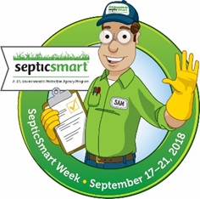

* Download the SepticSmart Week generic seal (no dates)
  + [SepticSmart Week Seal (no dates)](https://www.epa.gov/sites/production/files/styles/large/public/2018-03/septicsmart_week_seal_web_only_010318.jpg)

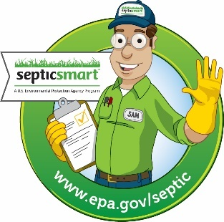

## **Blogs**

### **Using Education to Strengthen Emergency Preparedness for Septic Systems**

*National Environmental Health Association (NEHA)*

After the events of the past year, emergency preparedness has clearly emerged as one of the most important topics facing environmental health. The 2017 hurricane season left hundreds of billions of dollars-worth of damage in its wake. Meanwhile, wildfires in California burned over 1.2 million acres, resulting in five of the 20 most destructive fires in the state’s history. Despite the expansive media coverage these disasters generated, damage to wastewater treatment systems, especially private ones, was rarely discussed. Over 20% of U.S. households rely on a septic system, making them a key component to how wastewater is treated in this country. Septic systems can be damaged by hurricanes, wildfires, and a range of other disasters. Under flooded conditions, septic tanks can become dislodged and float out of the ground, heavy firefighting equipment can damage drain fields, and earthquakes can lead to drinking water contamination if septic tanks or pipes are damaged.

Including septic systems in preparedness efforts is essential to a strong recovery. Local and state health departments can provide guidance to septic system users in their communities and help residents identify qualified professionals if any repairs are needed. The best resource homeowners have, however, might be one they haven't considered: themselves. Being well versed with their septic system type, location, and components will help homeowners understand how different disaster events might impact their systems. Recognizing warning signs after a disaster and knowing when to call a licensed professional will also save homeowners from costly repairs down the road and protect their families' health. Taking steps to care for one's septic system, such as being mindful of what goes down the drain or keeping cars off the drain field, will also help systems function during and recover after a disaster hits.

From the national to the local level, more can and needs to be done to incorporate septic systems into emergency preparedness planning. While counties, states, and even federal agencies can grow their programs in this area, homeowners are best armed with a thorough understanding of how their system operates and who they should contact when something goes wrong. Unfortunately, years fraught with disaster events like 2017 are likely to become more frequent. Raging hurricane and wildfire seasons may strike again, and other disasters affecting septic systems will likely return. Building capacity at the state and local level is critical, but homeowner education is necessary to creating an efficient emergency preparedness program for septic systems.

Check out some of the free educational resources below to get started.

Environmental Protection Agency: https://www.epa.gov/septic

National Onsite Wastewater Recycling Association: http://septiclocator.org/

### **Teaming Up: How Partnerships Benefit Water Quality through Decentralized System Improvement**

*Chris Wieberg, Environmental Council of the States (ECOS)*

EPA’s Decentralized Wastewater Management Memorandum of Understanding Partnership (Partnership) works collaboratively at the national level to improve decentralized performance and protect the nation’s public health and water resources. The Environmental Council of the States (ECOS) joined the Partnership in the fall of 2017. The Partnership and ECOS missions alike prioritize ensuring the protection of the environment, in this case water quality, and public health.

**Decentralized System Partners**

One of the focuses of the Partnership is how to best leverage existing funding sources. This supports the aims of ECOS Resolution 16-5 which encourages the identification of financing approaches that help communities make sustainable decisions for drinking water and wastewater infrastructure investment. In this resolution, ECOS supports leveraging opportunities across federal, state, local, and private authorities to make more resources available to communities. Perhaps most importantly to ECOS, the Partnership exemplifies a way of sharing information that enables states to learn from one another.

Missouri’s Department of Natural Resources (Department) provides grants and loans to communities for wastewater and drinking water projects through its State Revolving Fund (SRF). By creating a partnership with a local non-profit, Ozark Water Watch (OWW), the Department has been able to utilize funding sources in the best way to improve water quality in southwest Missouri.

**Missouri’s Onsite Wastewater Treatment System Remediation Program**

Rapid population growth is occurring in southwest Missouri. Because more and more people are moving to areas which are not covered by municipal sewers, septic systems are going in the ground. Soils in this area of Missouri are generally rocky and thin which makes the typical onsite system consisting of a septic tank and drain field an ineffective form of wastewater treatment. The Department has teamed up with OWW to address this water quality issue. OWW is a non-profit organization dedicated to maintaining and improving the water quality of Missouri’s upper White River watershed. OWW administers a grant and loan program for residents of Missouri’s upper White River watershed to fix their failing onsite septic systems. This program is funded by the Department’s SRF. Depending on household income, residents may be eligible to receive up to a 100%, but not to exceed $30,000, grant and zero percent interest loan to repair or replace their failing septic tanks.

Since the program began in 2011, 289 systems have been replaced or rehabilitated. The program has prevented an estimated 6.7 million gallons of untreated sewage from entering the area’s water annually. Made available through the Department and OWW partnership, the Onsite Wastewater Treatment System Remediation Program empowers local residents to protect their water resources while also generating economic growth in the area.

### **On-site Septic Drainfield Innovations Around Vermont’s Lakes and Ponds**

*Mary Clark, President, State Onsite Regulators Association (SORA)*

For a tiny state, Vermont has lots of lakes and ponds, over 800 total. In the 1950’s and 60’s, many seasonal cottages were constructed on very small lots to serve a limited occupation and use. Today, there is pressure to use these cottages more frequently including as rentals or to convert to year-round residences. Many of these properties were developed before environmental regulations were in place and when little was known about soils and wastewater treatment. In fact, some of the earlier systems were designed to be partly in the groundwater table to facilitate the movement of water back into the environment. We now understand that a few feet of unsaturated soils are needed to treat the wastewater before entering groundwater. This will reduce the number of pathogens and nutrients that can impact wells, lakes and ponds and swimming areas.

Prior to purchasing a property on a lake or pond, know the septic limitations. The property may not be able to be converted into a full season home without a substantial investment. If you are considering renting a lakeside property, consider the risks and cost associated with repairing a failed wastewater system. Educate guests and renters on the use of a septic system…many have never used an on-site septic system and do not know what should not be flushed down the drain or understand the importance of water conservation.

If an owner wants to add a bedroom or upgrade their existing wastewater system, they may find themselves in a situation where they cannot expand. Waivers may be needed for replacement wastewater systems due to pre-existing site conditions. What is a homeowner to do, when their property cannot sustain a complying wastewater drainfield? Here are some innovative solutions to consider:

1. Install a composting toilet and low flow fixtures – while this solution won’t solve treating the graywater flows from sinks and showers, it will greatly reduce the volume, pathogen and nutrient load to the system. This can improve water quality and extend the life of the drainfield.
2. Work with your neighbors – consider sharing the septic tank and/or drainfield to reduce the area needed for both components. This may require easements and agreements but is a very feasible solution. It can be as simple as connecting two cottages or can be a community system to serve multiple properties.
3. Consider drip distribution – this is a newer technology in Vermont and other parts of the country, but it has some great benefits including providing superior pathogen and nutrient removal within the existing landscape. The ½ inch tubing can be located near trees and other landscape obstacles and terrain with the added benefit of irrigation.

Remember to perform regular maintenance tasks on your septic system. If you have an effluent filter at the outlet of your septic tank, clean it every 6 months. If you don’t have one, consider retrofitting your tank to install one. If you have a septic tank, have the tank pumped every 2-3 years. #SepticSmart

*Mary Clark, Environmental Program Manager, VT Department of Environmental Conservation, has over 40 years’ experience working in the onsite wastewater industry.*

Images to use along with blog post (from Mary Clark):





# **How to Guide: Governor, Mayor & Local SepticSmart Week Proclamations**

**From Christl Tate, NEHA**

SepticSmart Week typically takes place on the third week of September every year. This annual event focuses on educating homeowners and communities on the proper care and maintenance of their septic systems, as well as protecting public health, the environment, and one’s property value. To make the most of SepticSmart Week, EPA and the Decentralized Wastewater MOU Partnership have developed numerous outreach materials and resources available at [www.epa.gov/septic](http://www.epa.gov/septic)

## **Monthly Planning Guide to a SepticSmart Week Proclamation**

|  |  |  |
| --- | --- | --- |
| **MONTH** | **STEPS** | **IMPORTANT NOTES** |
| **May** | * Begin gathering information * Create a timeline | * Start early! |
| **June** | * Identify any established procedures around securing a proclamation * Ensure you have leadership support and make sure that is communicated in each step * Develop the wording for the proclamation (see EPA sample [proclamations](https://www.epa.gov/septic/septic-systems-outreach-toolkit)) * Draft memo from agency head to your state’s appointed health official (i.e. Secretary of Health, Surgeon General, etc.) * Draft memo from Health Official to Governor’s Office | * Save email from your leadership approving initiative as your Governor’s Office may ask for it * Make sure wording is short and to the point * Explain how it will benefit communities * Make sure the proclamation is in Microsoft Word for easy editing * Write the Governor’s Proclamation yourself in plain text, without any formatting. This makes it easy for the Governor’s Office to simply use your draft and add on their Governor Proclamation formatting * Check out examples of previous years’ proclamations (https://www.epa.gov/septic/septicsmart-week-2017-proclamations) |
| **July** | * Enlist support from other state/local health departments * Identify a point person in the process, whether at the State Health Department or Governor’s Office that you can check in with | * Keeping in touch will help you to know the status of your request and if there is anything missing that you need to submit   + Knowing this early on is important so that you do not run out of time to make corrections or additions   + Follow up with emails and phone calls * Ensure memos are sent from agency head to health official |
| **August** | * When you receive your proclamation, SHARE IT! Share it at local events, social media posts and news releases | * The proclamation gets posted on the governor’s webpage, bringing more attention to your cause * The proclamation adds more weight to your social media posts and increases the chance of it being picked up and shared across wider audiences |
| **September** | * Share! Share! Share! * Measure your impact! | * Metrics matter! As much as possible, identify the impact of your outreach activities. * Connect with partners to measure impact * Are calls regarding septic system operation and maintenance increasing? * Are local health departments seeing an increase in calls? |

## **Other Tips and Ideas to Promote SepticSmart Week**

* Take full advantage of the [materials](https://www.epa.gov/septic/septic-systems-outreach-toolkit) provided by EPA! These materials can be modified to fit your unique community regulations and needs. Your jurisdictional contact information can also be added.
* Share information with other jurisdictions as early as possible so they can have time to add it to their outreach calendar.
* Create partnerships with industry to promote SepticSmart Week and share informational flyers. Some septic system service providers have offered a discount for services booked during SepticSmart Week creating a win-win situation. This works well in the Val-Pack coupon mailers.
* Bus ads and billboards can be used throughout the state and reach a lot of people.
* Reach out to other agencies for opportunities to share information. Some ideas include:
* Highway signs or other “outdoor” advertising
* Permitting/Inspection
* Look within the health department for other outlets:
* Public Health Nurse home visits
* Healthy home inspections
* Restaurant inspections for establishments that rely on septic

# **Outreach Materials**

* Quick tips, flyers, website graphics, postcards, brochures, mail inserts, guides, door hangers can be found on [EPA's Septic Systems Outreach Toolkit](https://www.epa.gov/septic/septic-systems-outreach-toolkit).
* [The Do's and Don'ts of Your Septic System](https://www.epa.gov/sites/production/files/2017-07/documents/septicsmart_week_flyer_082415_508-v2.pdf) - most downloaded outreach graphic in 2017.

# **Images & Graphics**

* Use pictures to tell the story!
* Photos or images associated with each of the SepticSmart Week core messages:
  + Think at the Sink!  [English version](https://www.epa.gov/sites/production/files/styles/large/public/2018-04/think_at_the_sink_2018.jpg)  │ [Spanish version](https://www.epa.gov/sites/production/files/styles/large/public/2018-05/think_at_the_sink_2018_-_spanish-01.jpg)
  + Don't Strain Your Drain!  [​English version](https://www.epa.gov/sites/production/files/styles/large/public/2018-04/dont_strain_your_drain_2018.jpg)  │ [Spanish version](https://www.epa.gov/sites/production/files/styles/large/public/2018-05/dont_strain_your_drain_2018_-_spanish-01.jpg)
  + Keep It Clean!  [English version](https://www.epa.gov/sites/production/files/styles/large/public/2018-04/keep_it_clean_2018.jpg)  │ [Spanish version](https://www.epa.gov/sites/production/files/styles/large/public/2018-05/keep_it_clean_2018_-_spanish-01.jpg)
  + Shield Your Field!  [English version](https://www.epa.gov/sites/production/files/styles/large/public/2018-04/sheild_your_field_2018_-_2.jpg)  │ [Spanish version](https://www.epa.gov/sites/production/files/styles/large/public/2018-05/sheild_your_field_2018_-_2_-_spanish-01.jpg)
  + Protect It and Inspect It!  [English version](https://www.epa.gov/sites/production/files/styles/large/public/2018-04/protect_it_and_inspect_it_2018.jpg)  │ [Spanish version](https://www.epa.gov/sites/production/files/styles/large/public/2018-05/protect_it_and_inspect_it_2018_-_spanish-01.jpg)
  + Don't Overload the Commode!  [English version](https://www.epa.gov/sites/production/files/styles/large/public/2018-04/dont_overload_the_commode_2018.jpg)  │ [Spanish version](https://www.epa.gov/sites/production/files/styles/large/public/2018-05/dont_overload_the_commode_2018_-_spanish.jpg)
  + Pump Your Tank!  [English version](https://www.epa.gov/sites/production/files/styles/large/public/2018-04/pump_your_tank_2018.jpg)  │ [Spanish version](https://www.epa.gov/sites/production/files/styles/large/public/2018-05/pump_your_tank_2018_-_spanish-01.jpg)
* Use the home [infographic](https://www.epa.gov/sites/production/files/2016-08/documents/septicsmart_infographic_v2_081215.eps_508.pdf) with core SepticSmart messages:
  + **NEW** for 2018! [Do Your Part Infographic](https://www.epa.gov/sites/production/files/2018-05/documents/septicsmart_infographic_052318.pdf)

# **TV Spots**

* Local news stations, interviews, promoting SepticSmart Week
  + [WTAT News - South Carolina News Station](http://www.clipsyndicate.com/video/play/7094786/septic_smart_week_keeping_our_community_clean)
    - 9-minute interview with local expert promoting awareness for SepticSmart Week in South Carolina (from 2017)

# **Press Releases, Public Service Announcements (PSAs) & Radio Advertisements**

## **Press Release**

**From Christopher Lindsay, IAPMO**

FOR IMMEDIATE RELEASE Contact: XXXXXXXXX

(XXX) XXX-XXXX

xxxxxxxxx@xxxx.com

EPA’s Sixth Annual SepticSmart Week Promotes Public Health,

Water Conservation, and Economic Vitality

Washington, D.C. (Sept. X, 2018) — The United States Environmental Protection Agency (EPA), supported by state and local governments, the private sector, communities, and academia, will sponsor its sixth SepticSmart Week 2018, Sept. 17-21, an annual event focused on educating homeowners and communities on the proper care and maintenance of their septic systems.

More than one-fifth of U.S. households utilize an individual onsite system or small community cluster septic system to treat their wastewater. These systems treat and dispose of relatively small volumes of wastewater and include a wide range of individual and cluster treatment options to process household and commercial sewage. These systems go by such names as septic, decentralized wastewater treatment, cluster, package plants, on-lot, individual sewage disposal, and private sewage.

Onsite systems provide a cost-effective, long-term option for treating wastewater, particularly in sparsely populated areas. When properly installed, operated, and maintained, these systems help protect public health, preserve valuable water resources, and maintain a community’s economic vitality.

EPA’s SepticSmart initiative is a nationwide public education effort offering educational resources to homeowners, local organizations, and government leaders to explain how septic systems work and provide tips on how to properly maintain them. Organizations and individuals wishing to promote SepticSmart Week 2018 are encouraged to create public awareness about the event and share helpful tips, such as:

* + **Think at the Sink!:** What goes down the drain has a big impact on your septic system. Fats, grease, and solids can clog a system’s pipes and drainfield.
  + **Don’t Overload the Commode!**: A toilet is not a trash can. Disposable diapers and wipes, feminine hygiene products, coffee grounds, cigarette butts, and cat litter can damage a septic system.
  + **Don’t Strain Your Drain!**: Use water efficiently and stagger use of water-based appliances. Too much water use at once can overload a system that hasn’t been pumped recently.
  + **Shield Your Field!:** Tree and shrub roots, cars, and livestock can damage your septic drainfield.
  + **Keep It Clean!:** Contamination can occur when a septic system leaks due to improper maintenance. Be sure your drinking water is safe to drink by testing it regularly.
  + **Protect It and Inspect It!:** Regular septic system maintenance can save homeowners thousands of dollars in repairs and protect public health.
  + **Pump Your Tank!**: Ensure your septic tank is pumped at regularly intervals as recommended by a professional and/or local permitting authority.

SepticSmart Week 2018 encourages homeowners, wastewater professionals, and state, tribal, and local officials to design and maintain effective systems to promote public health, water conservation, and economic wellbeing. Be part of the solution by visiting www.epa.gov/septic for an abundance of resources and information.

## **Public Service Announcements (PSAs)**

**From the state of Washington**

* Septic Sam says ‘Save the Date’. SepticSmart Week is September 17th through the 21st. Each year EPA holds SepticSmart Week with outreach activities to encourage homeowners and communities to care for and maintain their septic systems. You wouldn’t drink out of your toilet would you? That is why information about maintenance and care is so important to help keep our water resources and our environment clean and safe. Septic Sam says call xxx-xxx-xxxx to learn more or go to [insert agency website].
* Septic Sam says ‘Do Your Part, Be SepticSmart’! Learn more about septic system care and maintenance during SepticSmart Week, September 17th through the 21st. Each year the EPA uses SepticSmart Week to reach out to homeowners and communities, to care for and maintain their septic systems. You wouldn’t drink out of your toilet would you? That’s why information about your septic system is vital in helping to prevent pollution and contamination of our environment and water resources. Call xxx-xxx-xxxx or go to [insert agency website].

## **Radio Ads**

**From the state of Alaska**

* If you’re buying a home in [insert State] you might be purchasing a septic system as well. Septic systems are effective and easy to maintain, but failing systems are a major cause of water pollution and can be expensive to replace. Learn the warning signs including slowly draining sinks, and toilets, or sewage odors in the house or yard. Better yet, get a professional to inspect your system, determine the age of the system, and make sure that it is properly sized for your current needs. Please check with local authorities for additional requirements in your area. This message is brought to you by [insert agency name].

* Out of sight and out of mind… Does that describe your relationship with your septic system? Proper maintenance of your septic system will affect how well it works, and, how long it lasts. And the most important part of maintenance is a regular inspection. Don’t wait until there’s a problem. Inspections will catch problems before they become serious and expensive to correct. The results can also suggest simple lifestyle changes such as conserving water. That will extend the life of your system. To learn more about your septic system, call your local [insert agency] office and request any materials designed especially for homeowners with septic systems. Protect your property, your family, and the environment, by getting to know your septic system. Please check with local authorities for additional requirements and recommendations in your area. This message is brought to you by [insert agency name].
* If you’re like most homeowners, you don’t think about what happens to things that go down the drain. But if you have a septic system, those things can come back to haunt you. Several things can damage your septic system and cause unpleasant and expensive problems. Don’t use your toilet as a trashcan… unless you want those items back. Call [insert agency name] to learn more about your septic system before it’s too late. Protect your property, your family, and your neighbors by getting to know your septic system. This message is brought to you by [insert agency name].

# **Talking Points for MOU Partners**

**From Michael Preston, NRWA**

* “SepticSmart Week is an important event in our community which reminds homeowners to maintain their septic systems. A well-managed septic system protects the health of the homeowner, as well as their neighbors and the community. Those who participate in SepticSmart Week should be commended.”
* “SepticSmart Week 2018 is an important step in raising awareness about septic systems and maintenance in our community. This campaign brings community members together and fosters good stewardship. Septic maintenance helps the community avoid costly repairs, maintain home property values, and protect local water sources.”
* “SepticSmart Week generates revenue for small businesses - septic installers, manufacturers and service providers. This small business growth supports local economies, jobs and families.”
* “[Organization name] is proud to participate in SepticSmart Week 2018. Proper septic maintenance and care is essential to protecting the property, health, and environment of our community(ies). We hope that homeowners take a moment this week to schedule service they may have put off and follow septic maintenance best practices.”

# **Personalize It!**

* Some of the brochures, pamphlets and postcards on [www.epa.gov/septic](http://www.epa.gov/septic) have white space on the front page to place your business card or use with a mailing label.
* Use these existing materials and add your own personalized mailing label or company logo.
  + [Homeowner's Brochure](https://www.epa.gov/sites/production/files/2015-06/documents/septicsmart_short_rack_brochure_english508_1.pdf)
  + [Homebuyer’s Guide](https://www.epa.gov/sites/production/files/2017-08/documents/170803-homebuyerssepticguidebrochurelayout_508c.pdf)
  + [Spring Postcard](https://www.epa.gov/sites/production/files/2018-05/documents/epa_septicsmart_septic_program_postcards.pdf)

# **Track Your Social Media Reach**

**From Bianca Poll and Dave Clark, Rural Community Assistance Program (RCAP)**

* Keep track of your social media efforts so you can report out on who you reached. As an MOU partner, it is extremely helpful for all of us to know the extent of our individual and collective efforts to send the SepticSmart message.
* Please use one of these free social media trackers to identify audience, reach, and how well a message is received (examples below). Then you can report back to the other partners with your results!
* [Google Analytics](https://analytics.google.com/analytics/web/) 
  + Track user activity on your website in real-time, such as: daily site visits, demographics of users, how they reached your site, how long they stay on your site, and which parts of your website are most and least popular.
* [Hootsuite](https://hootsuite.com/)
  + Measure social media ROI from all platforms in one place. The [free](https://hootsuite.com/plans/free) version allows for 1 user and 3 social media platforms). A free 30-day [trial](https://hootsuite.com/plans) for some advanced features is also available.
* [Facebook](https://www.facebook.com/business/a/page/page-insights)and [Twitter](https://analytics.twitter.com/about) Insights
* Metrics:
  + First identify your “Call to Action”. Are you trying to get people to go to your website? Are you trying to get people to share your post?
  + Second, identify the appropriate metric to use based on your call to action:
    - Measuring awareness: how far is your message spreading (volume, reach, exposure, amplification)
    - Measuring engagement: how many people are participating, how often and in what forms are they participating (likes, retweets, comments, replies, and participants)
    - Measuring traffic: are people moving though social media to your external site, and what do they do on your site (track URL shares, clicks, and conversions)
  + Third, analyze the buzz you are creating.
    - Use the tools above or generic tools such as:
      * [Social Mention](http://www.socialmention.com/): real-time social media search and analysis that tracks user sentiment, top keywords and users, hashtags, and sources of your search word. Type in a word, such as “[septic system](http://www.socialmention.com/search?q=septic+system&t=all&btnG=Search)” to search its mention online

# **Promotional Examples**

* [Vermont Public Radio broadcast "Talking Dirty: Discussing Your Septic System"](http://digital.vpr.net/post/talking-dirty-discussing-your-septic-system#stream/0) featuring SORA’s president, Mary Clark (Vermont Dept of Environmental Conservation)
* The below images are from **Kristine Rendon, Dave Cotton, and Dale Ladouceur, Michigan DEQ Onsite Wastewater Program**

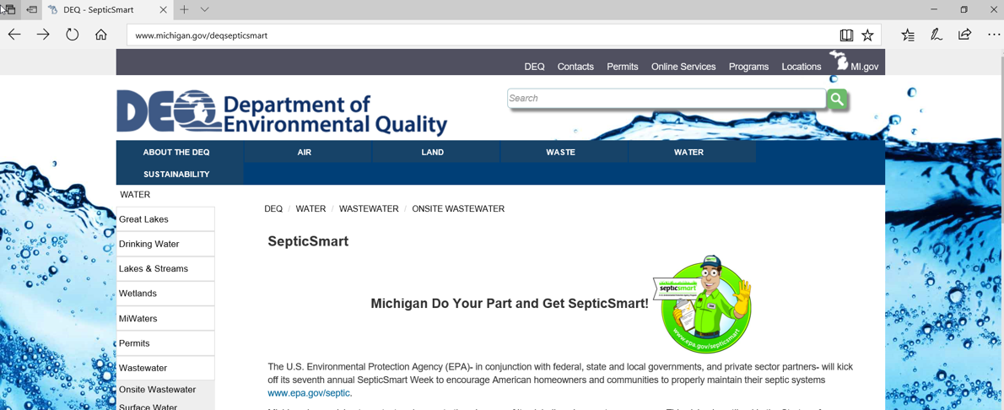

Image: Advertising on state DEQ website

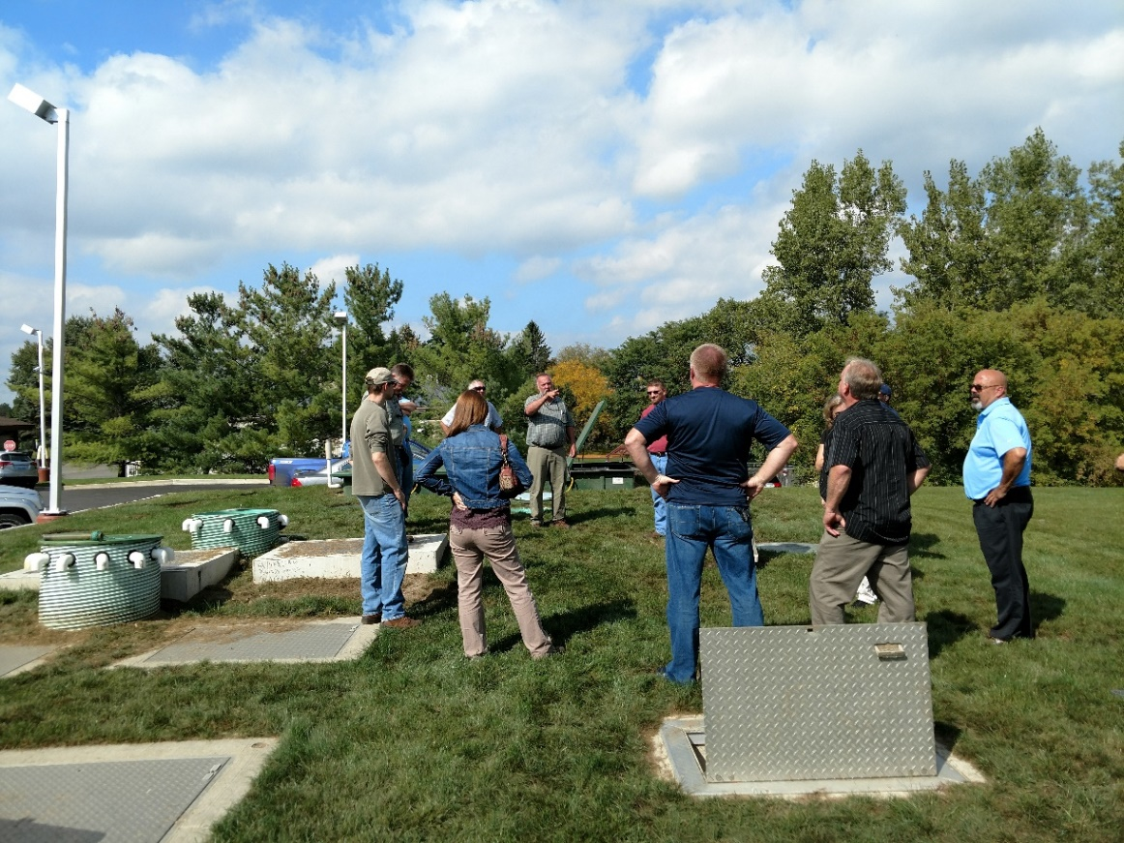

Image: Presentations across the state educating those on what it means to be SepticSmart (pictured – Dave Cotton holding hands-on training on septic systems)

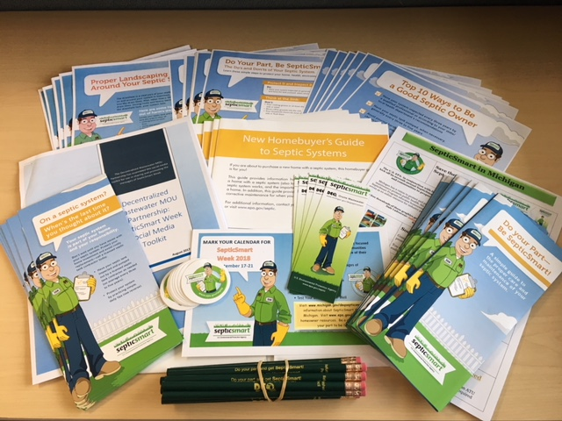

Image: Printed flyers and promotional material

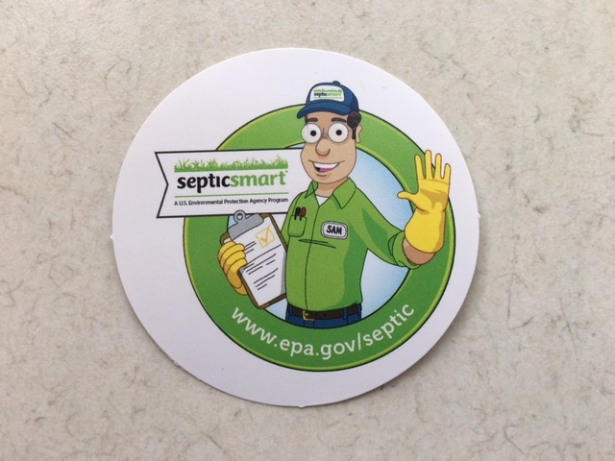

Image: Promotional stickers

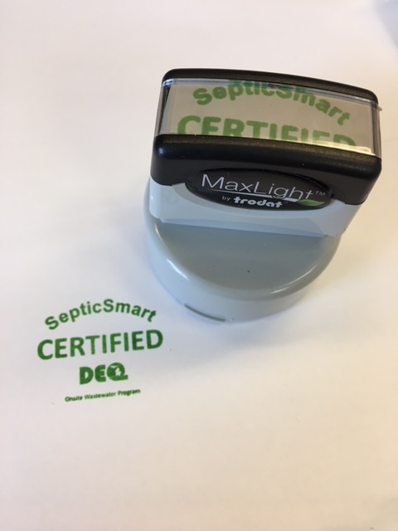

Image: SepticSmart “certified” stamp

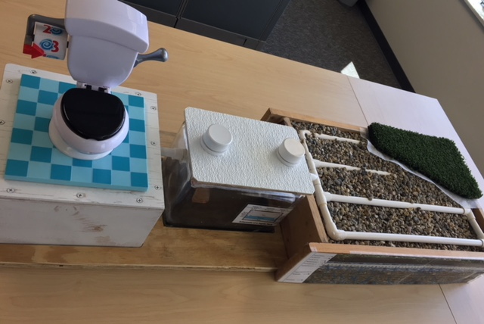

Image: Kid-friendly education/ interactive septic system

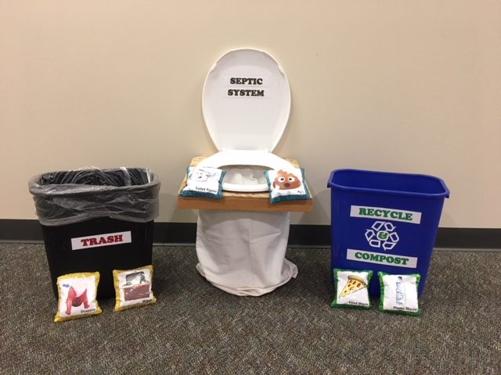

Image: “Not in my septic system” bean bag game